**ASSIGNMENT-6**

**Problem Statement :-** Write a program to show applications of different types of inheritances .

**Aim :-** To understand the concept of inheritance in C++ .

**Theory :-**

The capability of a class to derive properties and characteristics from another class is called **Inheritance**. Inheritance is one of the most important feature of Object Oriented Programming.  
**Sub Class:** The class that inherits properties from another class is called Sub class or Derived Class.  
**Super Class:**The class whose properties are inherited by sub class is called Base Class or Super class.

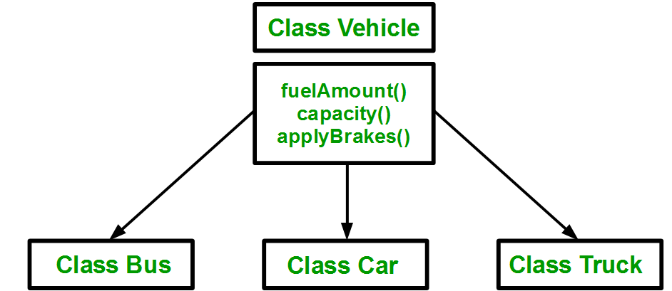

**Types of Inheritance in C++**

1. **Single Inheritance**:

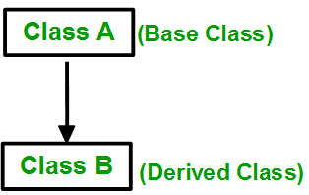

1. **Multiple Inheritance**

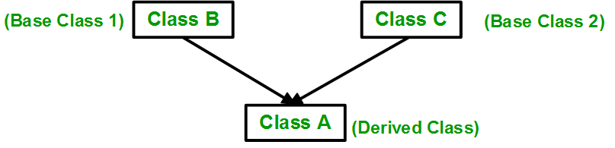

1. **Multilevel Inheritance**

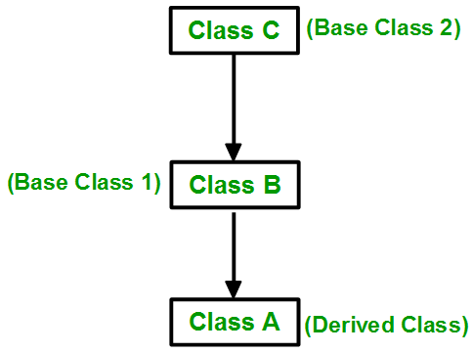

1. **Hierarchical Inheritance**:

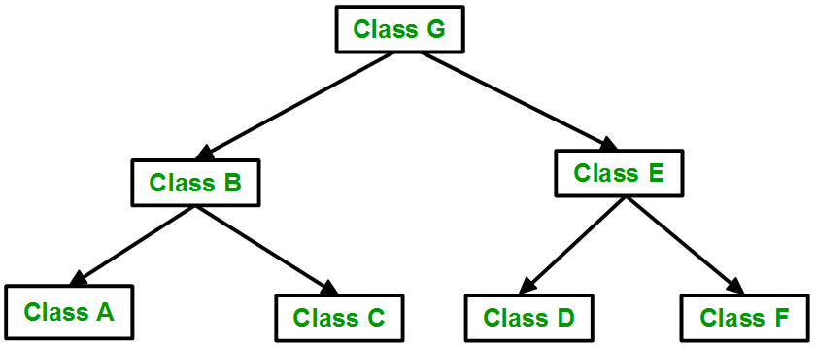

1. **Hybrid (Virtual) Inheritance**:

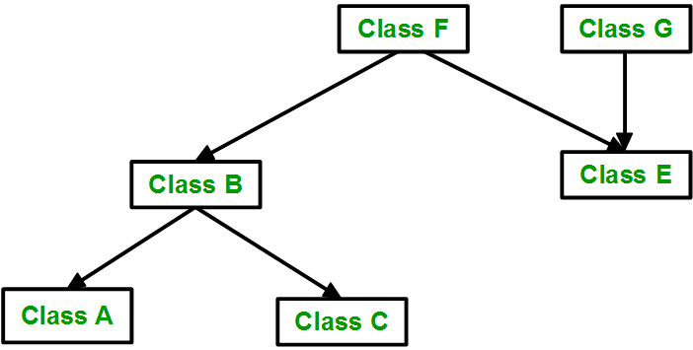

**Code :-**

**#include<iostream>**

**#include<cstring>**

**#include<cmath>**

**using namespace std;**

**typedef long long int ll;**

**class account**

**{**

**public:**

**ll acc;**

**string name;**

**int balance;**

**};**

**class saving:public account**

**{**

**public:**

**void getdata()**

**{**

**cout<<"Enter the name : ";**

**cin>>name;**

**cout<<"Enter the account no : ";**

**cin>>acc;**

**cout<<"Enter the balance : ";**

**cin>>balance;**

**}**

**void ci(double r)**

**{**

**int t;**

**cout<<"Enter the time for which you want CI : ";**

**cin>>t;**

**double cint=(balance*pow((1+r),1*t))-balance;**

**cout<<"Your Compound interest is : "<<int(cint)<<endl;**

**}**

**void withdrawl()**

**{**

**int w;**

**cout<<"Enter the amount you amt to withdraw : ";**

**cin>>w;**

**if(balance<w)**

**{**

**cout<<"Insufficient balance : "<<endl;**

**}**

**else**

**{**

**cout<<"Remaining balance is : "<<balance-w<<endl;**

**}**

**}**

**};**

**class current:public account**

**{**

**public:**

**void getdata()**

**{**

**cout<<"Enter the name : ";**

**cin>>name;**

**cout<<"Enter the account no : ";**

**cin>>acc;**

**cout<<"Enter the balance : ";**

**cin>>balance;**

**}**

**void chequebook()**

**{**

**if(balance>10000)**

**{**

**cout<<"Chequebook facility is available "<<endl;**

**}**

**else**

**{**

**cout<<"Chequebook facility is not available "<<endl;**

**}**

**}**

**void penalty()**

**{**

**int l=3000,amt;**

**cout<<"\nEnter the amount you want to withdraw : ";**

**cin>>amt;**

**if(balance-amt<3000)**

**{**

**cout<<"\nYour balance is very low and you will be charges fine of"<<100<<" Rs per day and remaining balance is "<<balance-amt<<endl;**

**}**

**else**

**{**

**cout<<"\nyou will not be charged any penalty and you remaining amout is "<<balance-amt<<endl;**

**}**

**}**

**};**

**int main()**

**{**

**cout<<"****Handling saving account****"<<endl;**

**saving s;**

**s.getdata();**

**s.ci(5);**

**s.withdrawl();**

**cout<<"\n****Handling Current account****"<<endl;**

**current c;**

**c.getdata();**

**c.chequebook();**

**c.penalty();**

**}**

**Output :-**

